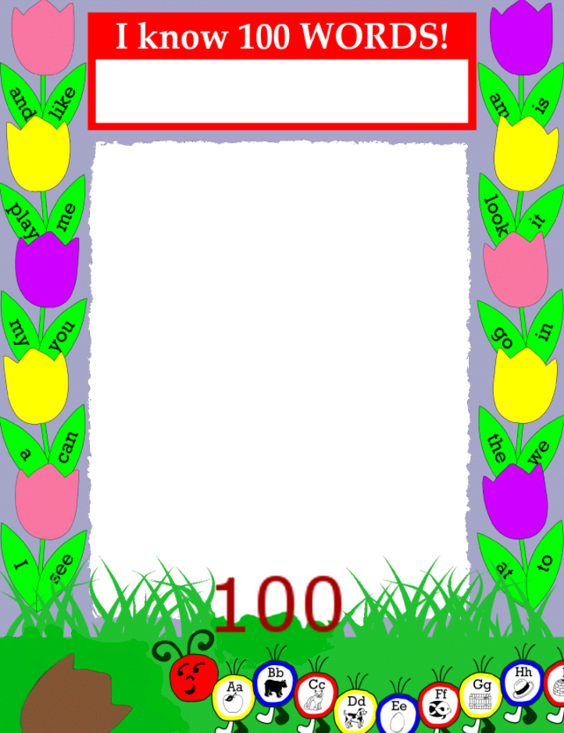

**Student Picture Here**

**Student Name Here**