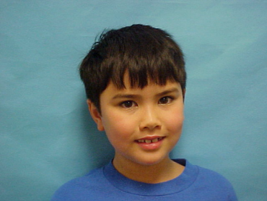  

**CLASS: ASMD**

**DOB: 7/21/2006**

**EXPIRES: 7/21/2006**

**EYES: BROWN HT: 4’5”**

**Priscilla Jenkins**

**4th Grade**

**Zavala Elementary**

**CLASS: ASMD**

**DOB: 7/21/2006**

**EXPIRES: 7/21/2006**

**EYES: BROWN HT: 4’5”**

**Blaine Helwig**

**5th Grade**

**Graham Elementary**

**CLASS: ASMD**

**DOB: 7/21/2006**

**EXPIRES: 7/21/2006**

**EYES: BROWN HT: 4’5”**

**Bo Bo The Clown**

**3rd Grade**

**Fun Place Elementary**

  

**CLASS: ASMD**

**DOB: 7/21/2006**

**EXPIRES: 7/21/2006**

**EYES: BROWN HT: 4’5”**

**Ramona Marking**

**4th Grade**

**Houston Elementary**

  

**CLASS: ASMD**

**DOB: 7/21/2006**

**EXPIRES: 7/21/2006**

**EYES: BROWN HT: 4’5”**

**Blaine Helwig**

**5th Grade**

**Graham Elementary**

**CLASS: ASMD**

**DOB: 7/21/2006**

**EXPIRES: 7/21/2006**

**EYES: BROWN HT: 4’5”**

**Blaine Helwig**

**5th Grade**

**Graham Elementary**

**CLASS: ASMD**

**DOB: 7/21/2006**

**EXPIRES: 7/21/2006**

**EYES: BROWN HT: 4’5”**

**Blaine Helwig**

**5th Grade**

**Graham Elementary**

  

**CLASS: ASMD**

**DOB: 7/21/2006**

**EXPIRES: 7/21/2006**

**EYES: BROWN HT: 4’5”**

**Blaine Helwig**

**5th Grade**

**Graham Elementary**