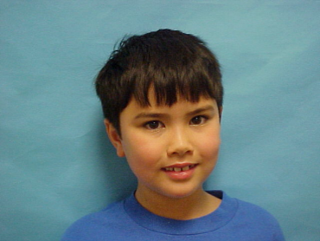  

**DOB: 7/21/2016**

**EXPIRES: 7/21/2017**

**EYES: Brown**

**HT: 4’5”**

**John Glenn**

**3rd Grade**

**Mercury Elementary**

**DOB: 7/21/2016**

**EXPIRES: 7/21/2017**

**EYES: Brown**

**HT: 4’5”**

**Blaine Helwig**

**5th Grade**

**Graham Elementary**

  

**DOB: 7/21/2016**

**EXPIRES: 7/21/2017**

**EYES: Brown**

**HT: 4’5”**

**Sally Struthers**

**5th Grade**

**All In Family Elementary**

**DOB: 7/21/2016**

**EXPIRES: 7/21/2017**

**EYES: Brown**

**HT: 4’5”**

**Priscilla Jenkins**

**4th Grade**

**Zavala Elementary**

  

**DOB: 7/21/2016**

**EXPIRES: 7/21/2017**

**EYES: Brown**

**HT: 4’5”**

**Blaine Helwig**

**5th Grade**

**Graham Elementary**

**DOB: 7/21/2016**

**EXPIRES: 7/21/2017**

**EYES: Brown**

**HT: 4’5”**

**Blaine Helwig**

**5th Grade**

**Graham Elementary**

  

**DOB: 7/21/2016**

**EXPIRES: 7/21/2017**

**EYES: Brown**

**HT: 4’5”**

**Blaine Helwig**

**5th Grade**

**Graham Elementary**

**DOB: 7/21/2016**

**EXPIRES: 7/21/2017**

**EYES: Brown**

**HT: 4’5”**

**Blaine Helwig**

**5th Grade**

**Graham Elementary**