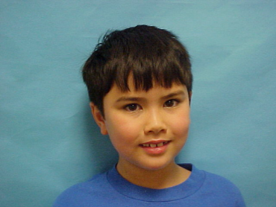  

**DOB: 7/21/2016**

**EXPIRES: 7/21/2017**

**EYES: Brown HT: 4’5”**

**Blaine Helwig**

**5th Grade**

**Graham Elementary**

**DOB: 7/21/2016**

**EXPIRES: 7/21/2017**

**EYES: Brown HT: 4’5”**

**John Doe**

**3th Grade**

**Becker Elementary**

  

**DOB: 7/21/2016**

**EXPIRES: 7/21/2017**

**EYES: Brown HT: 4’5”**

**Jeff Flake**

**4th Grade**

**Roberts Elementary**

**DOB: 7/21/2016**

**EXPIRES: 7/21/2017**

**EYES: Brown HT: 4’5”**

**John McCain**

**3rd Grade**

**Franklin Elementary**

  

**DOB: 7/21/2016**

**EXPIRES: 7/21/2017**

**EYES: Brown HT: 4’5”**

**Jesus Gonzalez**

**5th Grade**

**Andrews Elementary**

**DOB: 7/21/2016**

**EXPIRES: 7/21/2017**

**EYES: Brown HT: 4’5”**

**Priscilla Amara Lopez**

**4th Grade**

**Forest Creek Elementary**

  

**DOB: 7/21/2016**

**EXPIRES: 7/21/2017**

**EYES: Brown HT: 4’5”**

**Barry Goldwater**

**5th Grade**

**Joshua Tree Elementary**

**DOB: 7/21/2016**

**EXPIRES: 7/21/2017**

**EYES: Brown HT: 4’5”**

**Merridith Brooks**

**5th Grade**

**Phoenix Elementary**