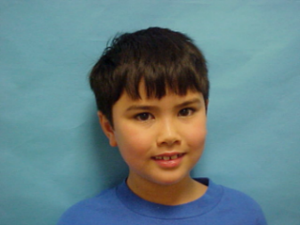  

**NAME: Blaine A. Helwig**

**GRADE: Fourth Grade**

**SCHOOL: Graham Elementary**

**ISSUE DATE: 10 December 2018**

**NAME: Buster Keaton**

**GRADE: Sixth Grade**

**SCHOOL: Hart Elementary**

**ISSUE DATE: 25 October 2018**

  

**NAME: Chris Summers**

**GRADE: Fourth Grade**

**SCHOOL: Morningside ES**

**ISSUE DATE: 2 September 2018**

**NAME: Robert Ludlum**

**GRADE: Second Grade**

**SCHOOL: Public School No. 345**

**ISSUE DATE: 22 November 2018**

  

**NAME: Bruce Willis**

**GRADE: Second Grade**

**SCHOOL: Hilton Head El School**

**ISSUE DATE: 16 August 2018**

**NAME: Jesus H. Christopher**

**GRADE: First Grade**

**SCHOOL: Norman Elementary**

**ISSUE DATE: 5 January 2018**

  

**NAME: Mark Anthony**

**GRADE: Seventh Grade**

**SCHOOL: Highland Park ES**

**ISSUE DATE: 27 September 2018**

**NAME: J Lo**

**GRADE: Third Grade**

**SCHOOL: Pecan Grove ES**

**ISSUE DATE: 12 January 2018**