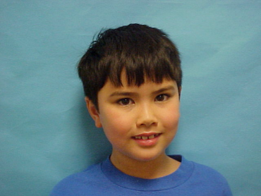  

**CLASS: ASMD**

**DOB: 7/21/2006**

**EXPIRES: 7/21/2006**

**EYES: BROWN HT: 4’5”**

**Phil Mickleson**

**5th Grade**

**PGA Elementary**

**CLASS: ASMD**

**DOB: 7/21/2006**

**EXPIRES: 7/21/2006**

**EYES: BROWN HT: 4’5”**

**Blaine Helwig**

**4th Grade**

**Graham Elementary**

  

**CLASS: ASMD**

**DOB: 7/21/2006**

**EXPIRES: 7/21/2006**

**EYES: BROWN HT: 4’5”**

**Jerry Brown**

**3rd Grade**

**Oakland Elementary**

**CLASS: ASMD**

**DOB: 7/21/2006**

**EXPIRES: 7/21/2006**

**EYES: BROWN HT: 4’5”**

**Blaine Helwig**

**4th Grade**

**Graham Elementary**

  

**CLASS: ASMD**

**DOB: 7/21/2006**

**EXPIRES: 7/21/2006**

**EYES: BROWN HT: 4’5”**

**Willie Brown**

**4th Grade**

**Heart Elementary**

**CLASS: ASMD**

**DOB: 7/21/2006**

**EXPIRES: 7/21/2006**

**EYES: BROWN HT: 4’5”**

**Maxine Waters**

**4th Grade**

**Forest Hills Elementary**

 

**CLASS: ASMD**

**DOB: 7/21/2006**

**EXPIRES: 7/21/2006**

**EYES: BROWN HT: 4’5”**

**Betty Jenkins**

**4th Grade**

**Blackshear Elementary**

**CLASS: ASMD**

**DOB: 7/21/2006**

**EXPIRES: 7/21/2006**

**EYES: BROWN HT: 4’5”**

**Blaine Helwig**

**4th Grade**

**Graham Elementary**