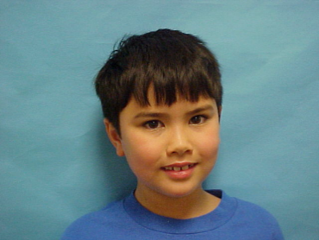

**DOB: 7/21/2016**

**EXPIRES: 7/21/2017**

**EYES: Brown HT: 4’5”**

**Barack Obama**

**4th Grade**

**Chicago Elementary**

**DOB: 7/21/2016**

**EXPIRES: 7/21/2017**

**EYES: Brown HT: 4’5”**

**Abe Lincoln**

**5th Grade**

**Sprinfield Elementary**

**DOB: 7/21/2016**

**EXPIRES: 7/21/2017**

**EYES: Brown HT: 4’5”**

**Blaine Helwig**

**5th Grade**

**Graham Elementary**



**DOB: 7/21/2016**

**EXPIRES: 7/21/2017**

**EYES: Brown HT: 4’5”**

**Michael Jordan**

**4th Grade**

**Chicago Bulls Elementary**

**DOB: 7/21/2016**

**EXPIRES: 7/21/2017**

**EYES: Brown HT: 4’5”**

**Muddy Waters**

**5th Grade**

**Delta Blues Elementary**

**DOB: 7/21/2016**

**EXPIRES: 7/21/2017**

**EYES: Brown HT: 4’5”**

**Joe Biden**

**5th Grade**

**PS 11 Elementary**

**DOB: 7/21/2016**

**EXPIRES: 7/21/2017**

**EYES: Brown HT: 4’5”**

**Al Capone**

**3rd Grade**

**RICO Elementary**

**DOB: 7/21/2016**

**EXPIRES: 7/21/2017**

**EYES: Brown HT: 4’5”**

**Buddy Guy**

**5th Grade**

**Chicago Blues Elementary**

**DOB: 7/21/2016**

**EXPIRES: 7/21/2017**

**EYES: Brown HT: 4’5”**

**Barack Obama**

**4th Grade**

**Chicago Elementary**